Scale Drawing

1. (i) Make accurate drawings of each shape below, using the scale indicated.
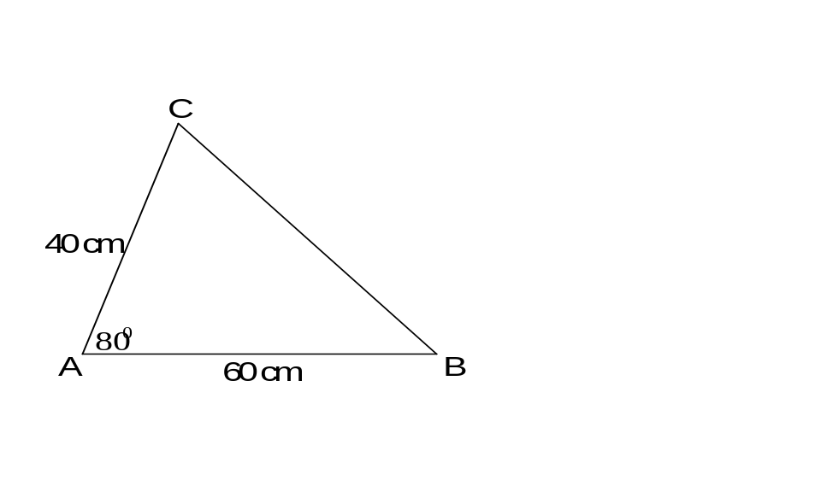 (ii) Use your drawings to find the distance BC.
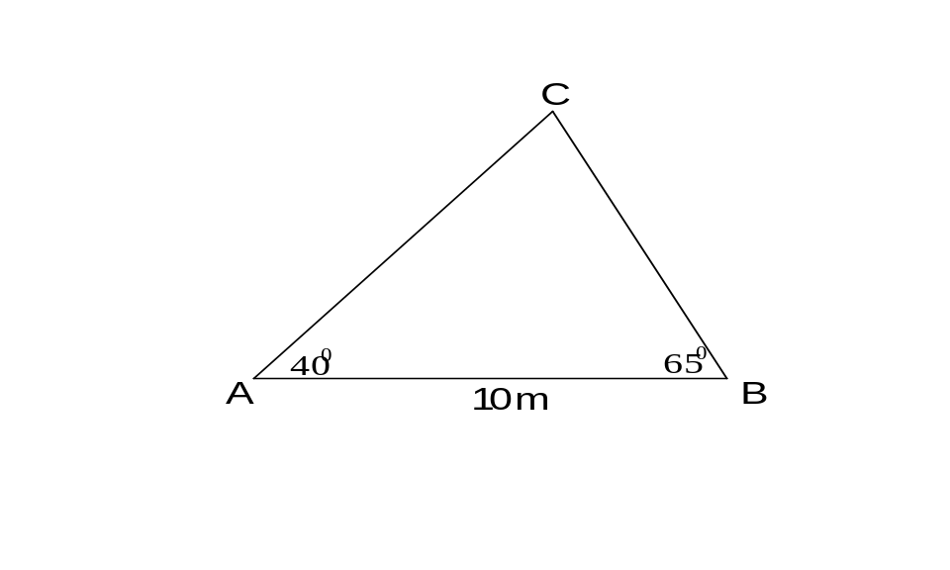

(a) (b)

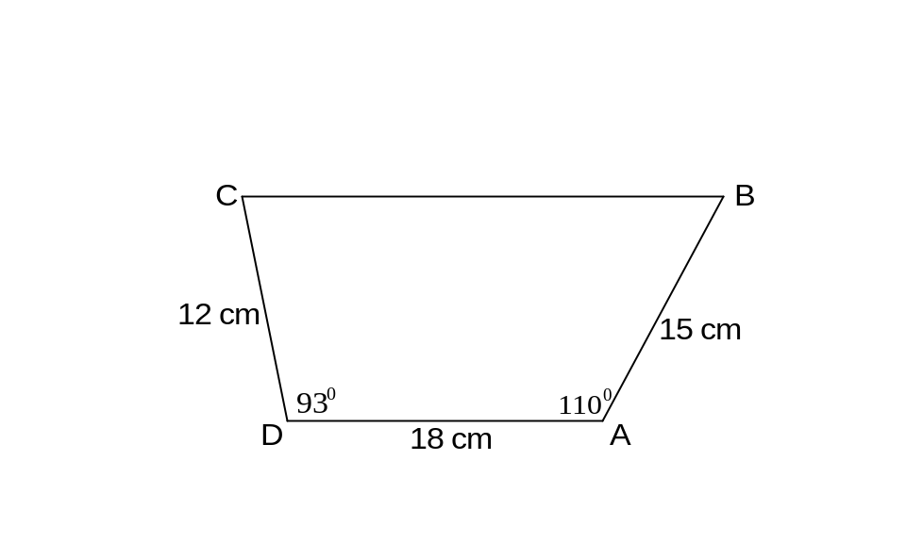 Scale 1 : 10 Scale 1 cm : 2 m

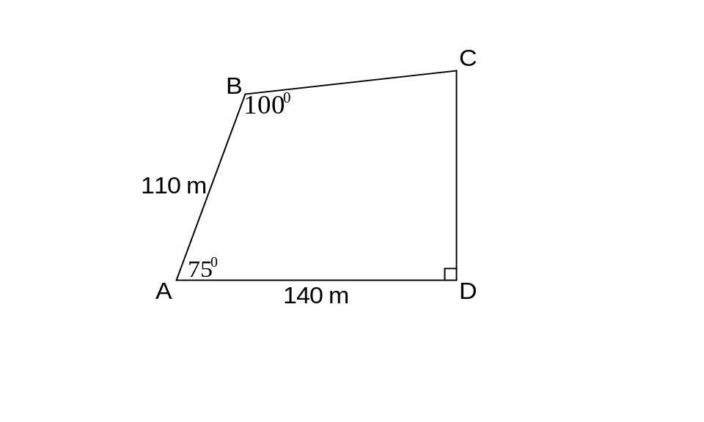
2. Make a scale drawing of each shape and use your drawing to find the length of BC.
(a) (b)

Scale 1 : 3 Scale 1 cm : 20 m
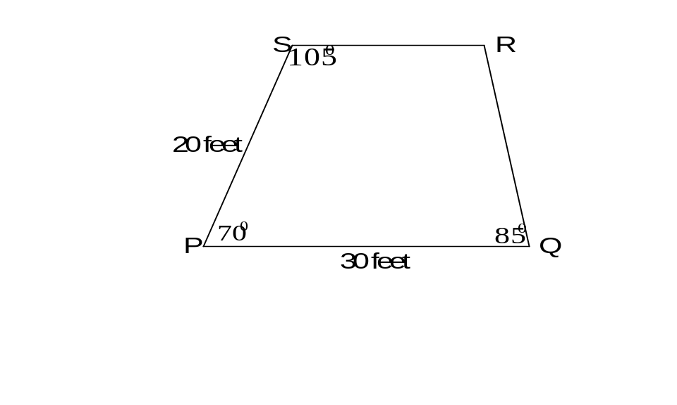
3. The diagram opposite shows the floor of a theatre
stage, PQRS.

- Make an accurate drawing of this stage.
( use a scale of 1 cm : 5 feet )

- A mark has to be made on the stage where the
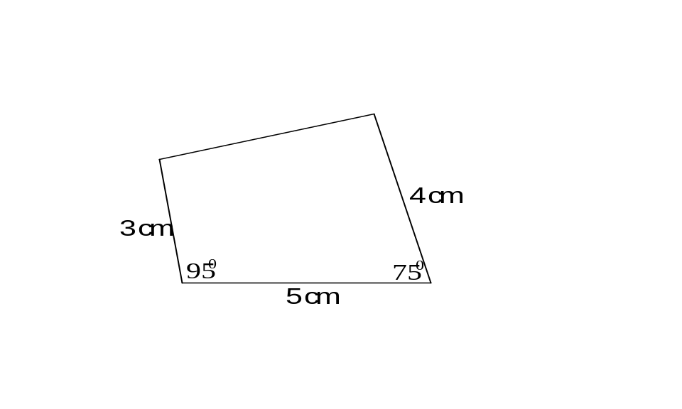diagonals PR and QS cross.
How far is this mark from the point P?

4. A piece of glass from a stained glass window
is shown opposite.
A larger piece of glass, the same shape is to be
made using a scale of 2:1.

Make an accurate drawing of this larger piece
of glass.

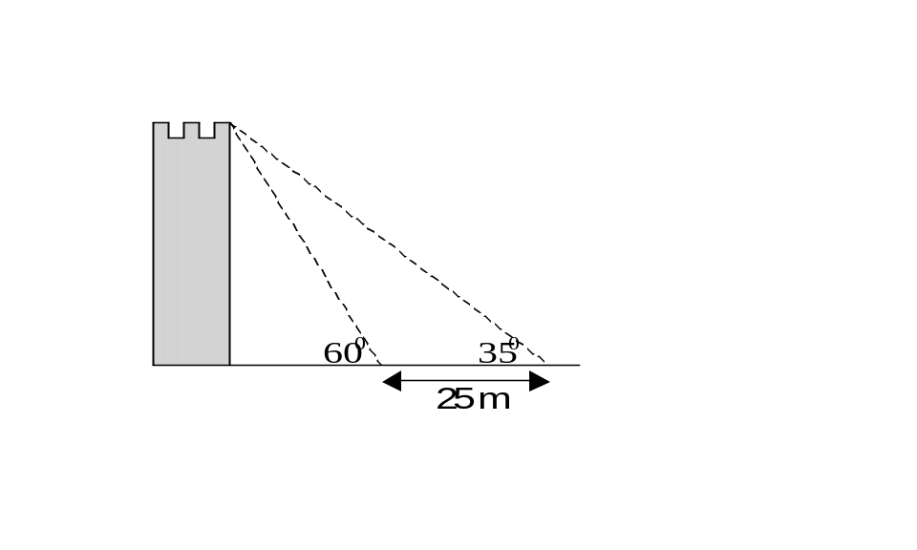5. The diagram opposite shows a tower.
From two points 25 metres apart, the
angles of elevation to the top of the
tower are 35⁰ and 60⁰.

(a) Make a scale drawing of the diagram.

(b) Use your drawing to find the height of
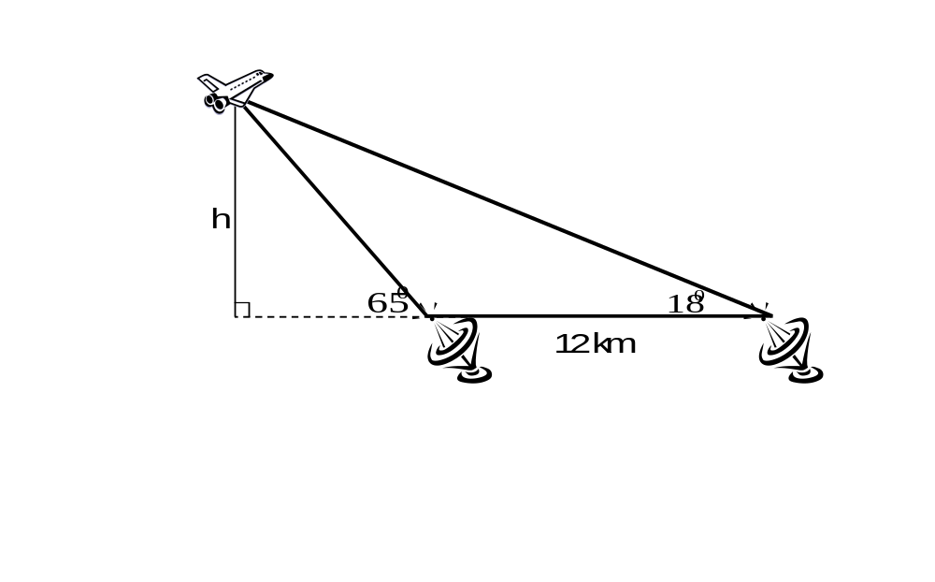 the tower.

6. Two tracking stations,
12 km apart, are tracking
a space shuttle, as shown.
The angle of elevation
from one station to the
shuttle is 65⁰ and from the
other the angle of elevation
is 18⁰.

- Make a scale drawing of the diagram.

(b) Use your drawing to find the height, h.

7. Two aeroplanes, 15 kilometres apart, are the same height above the ground, as shown.
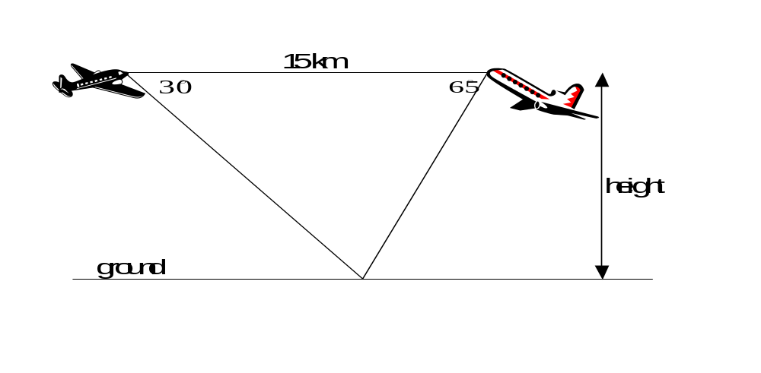 The angle of depression from one aeroplane to the ground is 30° and from the other is 65°.

(a) Make an accurate sketch using a scale of 1 cm : 3 km.

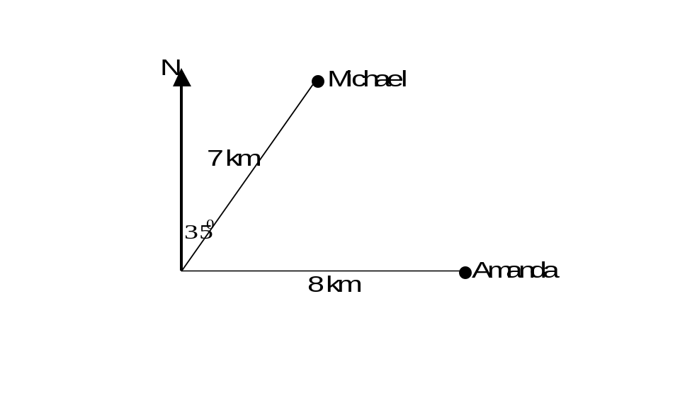 (b) Use your sketch to find the height the aeroplanes are above the ground.

8. Amanda and Michael leave the same campsite
and set off in different directions.
Michael walks 7 kilometres on a bearing of 035⁰
and Amanda walks 8 kilometres due east.

- Using a scale of 1 cm: 1 km make a scale
drawing of their journey.

(b) Use your drawing to find how far apart Amanda
and Michael are?

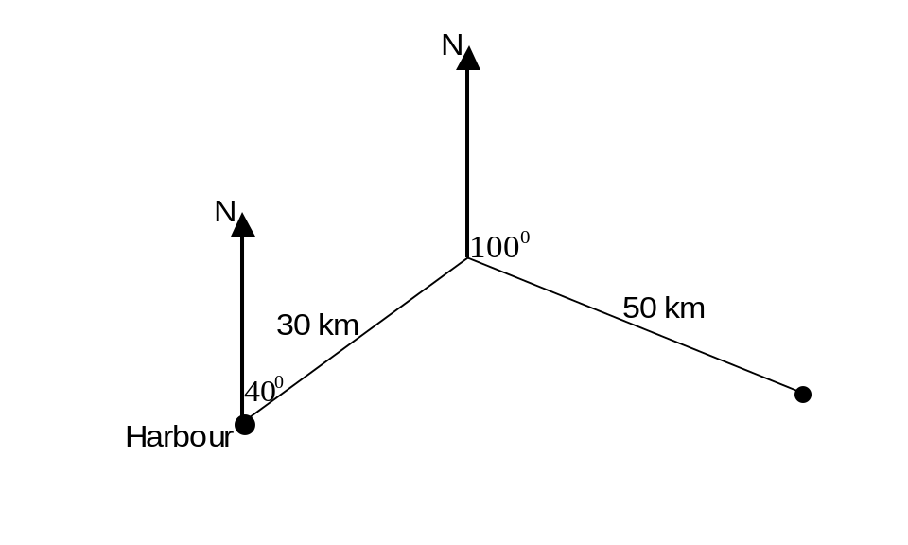9. The sketch below shows the journey of a ship from a harbour.

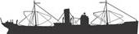

The ship leaves the harbour and sails 30 km on a bearing of 040⁰ and then sails 50 km
on a bearing of 100⁰.

- Using a scale of 1 cm: 5 km, make a scale drawing of the ship’s course.

- Use your drawing to find the actual distance of the ship from the harbour.

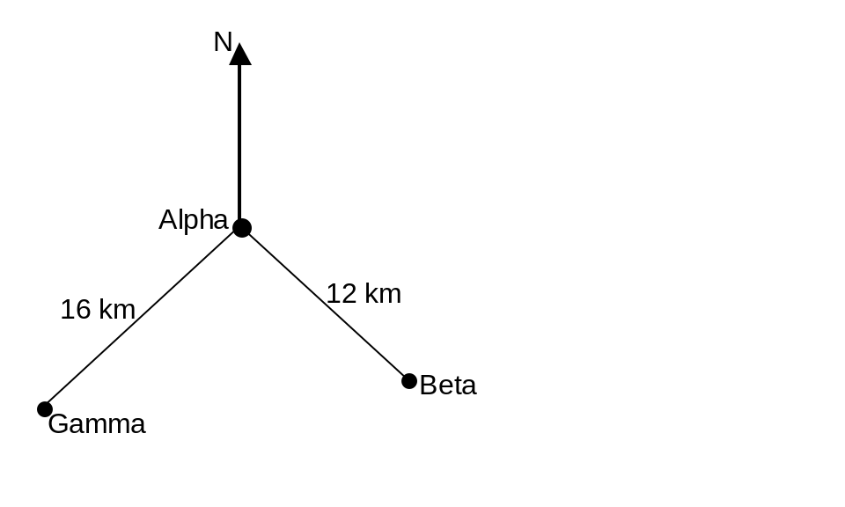
10. Three oil platforms, Alpha, Beta and Gamma
are situated in the North Sea.
Beta is 12 km from Alpha and is on a bearing of
145⁰ from Alpha.
Gamma is 16 km from Alpha and is on a bearing
of 220⁰ from Alpha.

- Using a scale of 1 cm: 2 km make a scale
Drawing.

- Use your drawing to find the distance between
Beta and Gamma.

- Use your drawing to find the bearing of Gamma
from Beta.

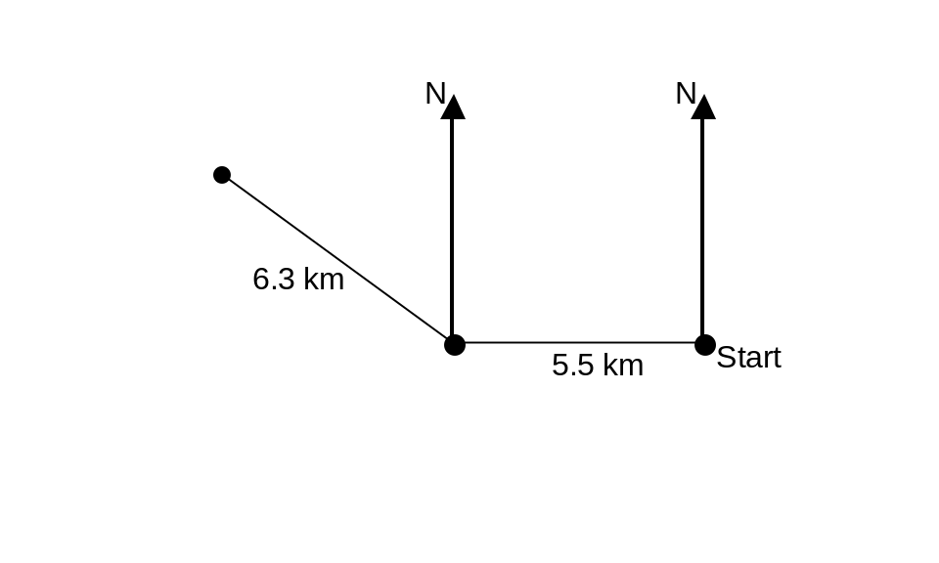

11. David takes part in a cross-country race.
He leaves the starting point of the race
and runs due west for 5.5 km before
changing direction and running 6.3 km
in a north-west direction.

- Make a scale drawing of David’s run.

(b) Use your drawing to find how far David
is from the starting point.

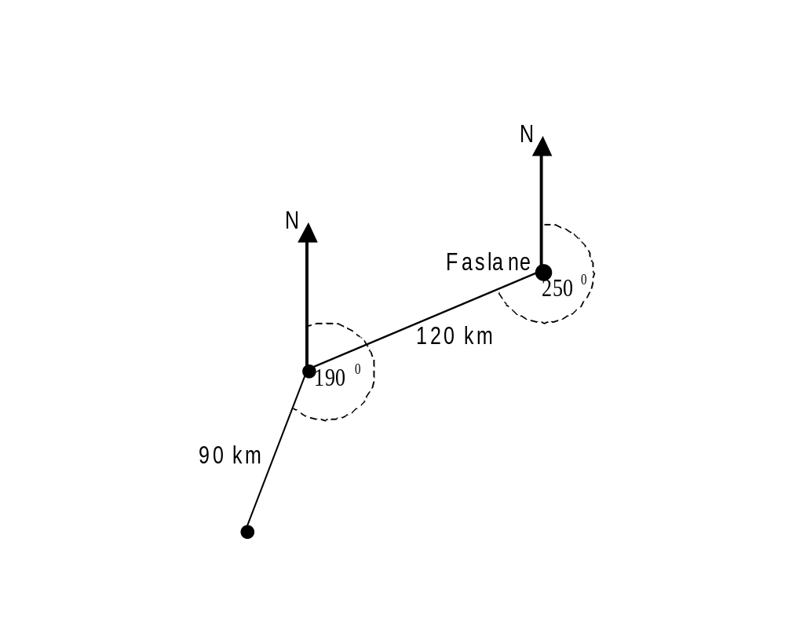12. A submarine leaves Faslane in Scotland
and sails into the Atlantic Ocean on a bearing
of 250⁰ for a distance of 120 km before
changing course and sailing on a bearing of
190⁰ for 90 km.

- Make a scale drawing of this information.

(b) Find the distance and the bearing of the
submarine from Faslane.

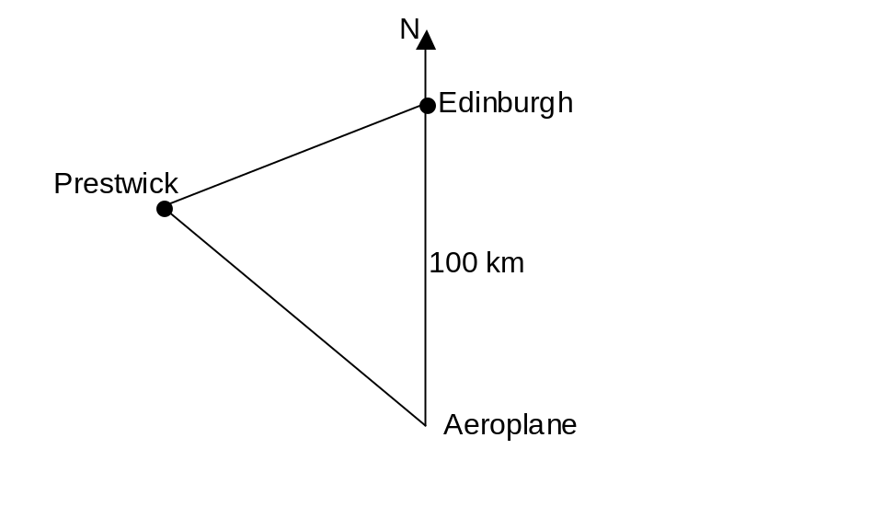

13. An aeroplane flying to Edinburgh is 100 km
due south of Edinburgh when the pilot is told
to change direction because of fog.
He is told to fly to Prestwick on a bearing of 320⁰.
The bearing of Prestwick from Edinburgh is 240⁰.

- Make a scale drawing of the diagram shown.

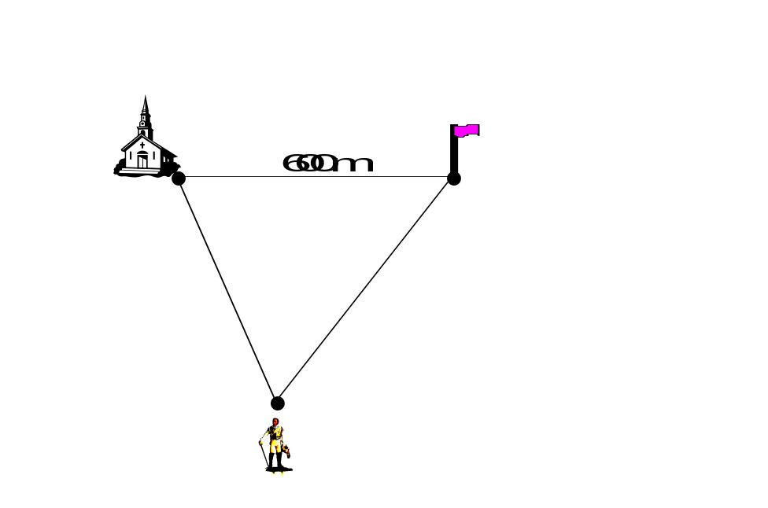(b) Use the scale drawing to find the distance of
the aeroplane from Prestwick.
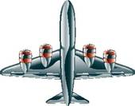

14. A church is 600 metres due west of a flagpole.
A statue is on a bearing of 160⁰ from the church
and on a bearing of 220⁰ from the flagpole.

(a) Using a scale of 1 cm: 100 m make a scale
drawing of the three landmarks.

- Use your scale drawing to find the distance
from the church to the statue.

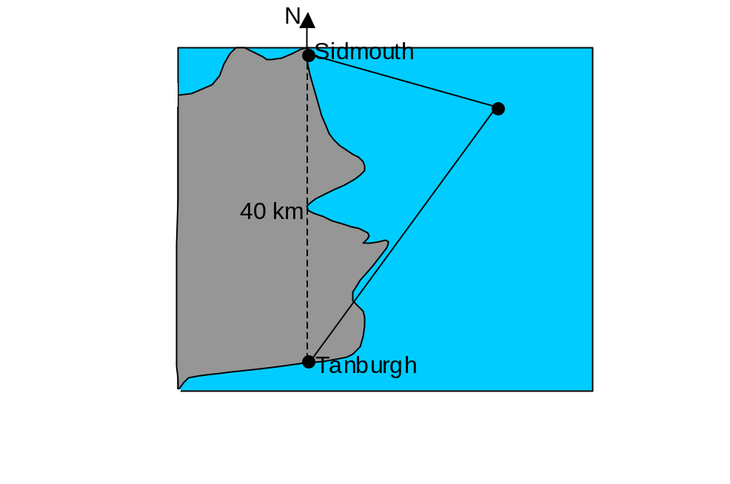

15. The diagram shows the ports of Sidmouth and

Tanburgh.
Sidmouth is 40 km due north of Tanburgh.
An oil tanker out at sea is on a bearing of 095⁰
from Sidmouth and on a bearing of 035⁰ from
Tanburgh.
- Show this information in a scale drawing.

(b) Find the distance of the oil tanker from
Tanburgh.

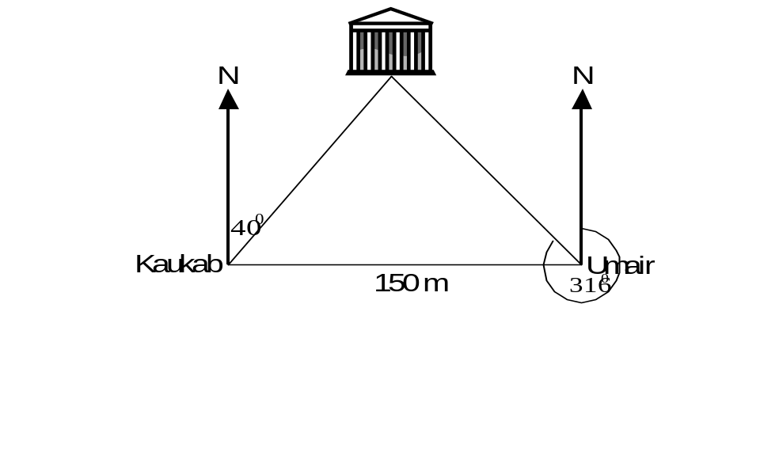
16. Kaukab and Umair are standing 150 metres apart.
Umair is due East of Kaukab.
A temple is on a bearing of 040° from Kaukab
and on a bearing of 316° from Umair.

(a) Show this information in a scale drawing.

(b) How far is Kaukab from the temple?

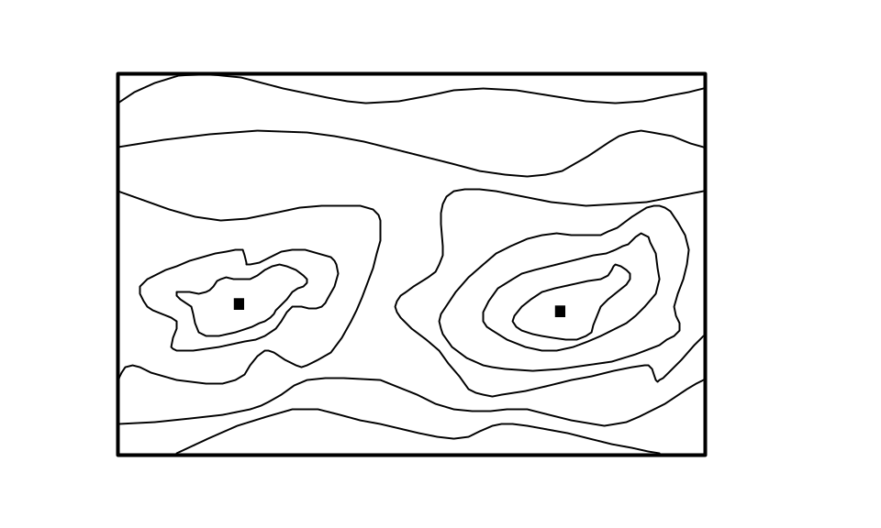

17. The diagram shows part of a map.
The two dots represent hilltops.

The scale of the map is 1:50 000.

Calculate the actual distance between
hilltops. Give your answer in kilometres.


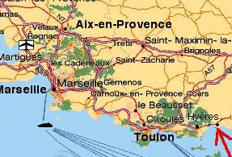

18. The diagram shows a map of part of
Southern France.
Given the scale of the map is 1:1300000,
find the actual distance from Marseille
to Toulon.

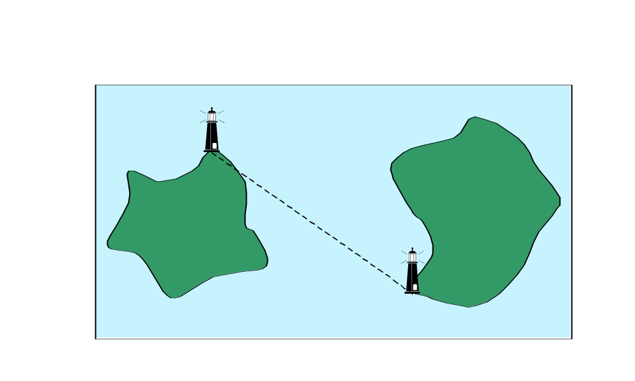

19. The diagram shows two lighthouses
situated on two small islands.
The scale of the map is 1: 200 000.

Use the diagram to find the actual
distance between the lighthouses
in kilometres.

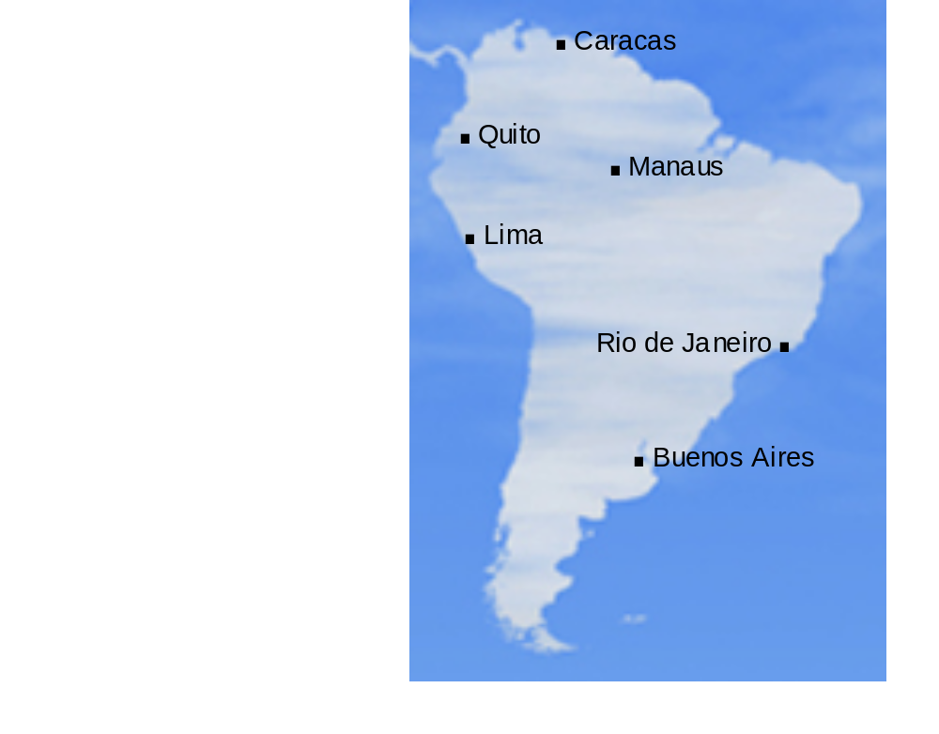

20. The diagram opposite shows a
map of South America.
The scale of the map is
1 : 70 000 000.

Use the diagram to find the actual
distances of

- Manaus to Buenos Aires

- Rio de Janeiro to Quito

- Caracas to Lima.

Give your answers in kilometres.

