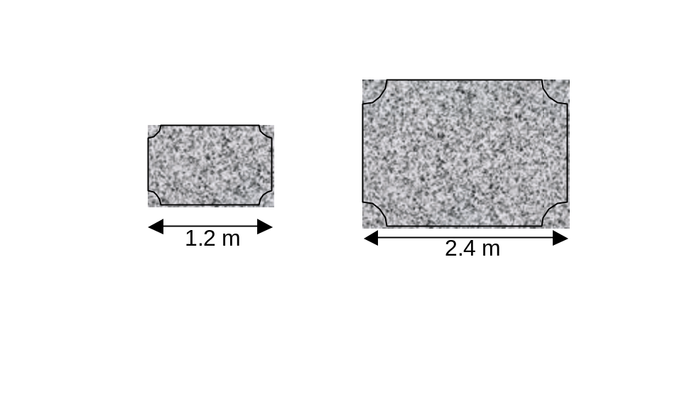Similar Areas and Volumes

1. Two kitchen worktops are similar in shape.
The area of the smaller worktops is 6.8 m².

Calculate the area of the larger worktop.

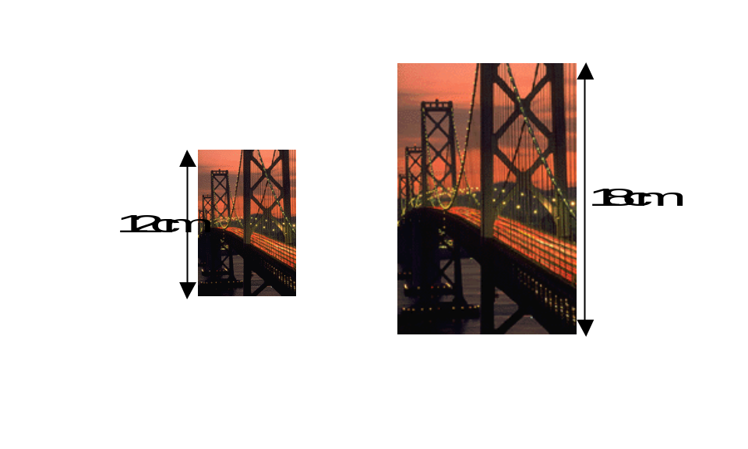

2. A photograph and its enlargement are
similar in shape.
The smaller photograph has an area of
56 cm² .

Calculate the area of the larger photograph.

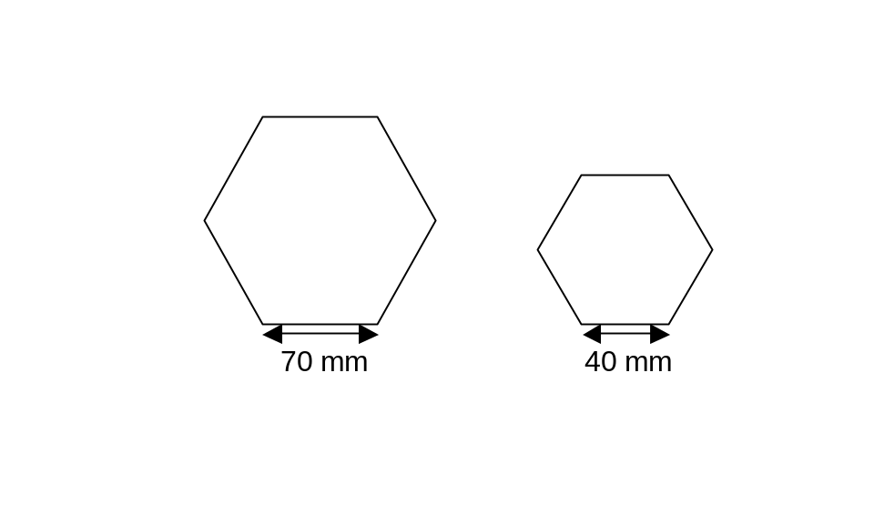

3. Two hexagons are mathematically
similar in shape.
The larger hexagon has an area of 7350 mm².

Find the area of the smaller hexagon.

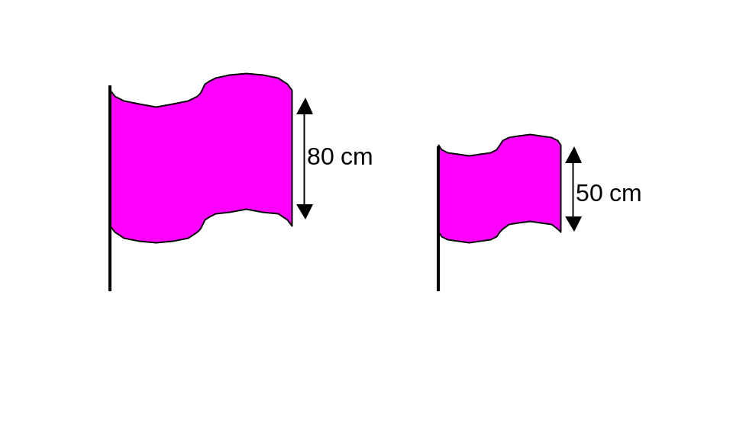

4. Two flags are mathematically similar.
The larger flag has an area of 7680cm².

Find the area of the smaller flag.

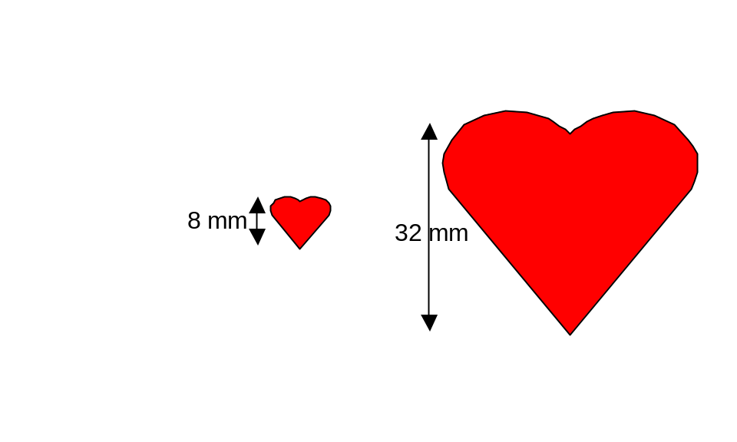

5. Two heart shaped symbols are similar in shape.
The smaller shape has an area of 25 mm².

Calculate the area of the larger shape.

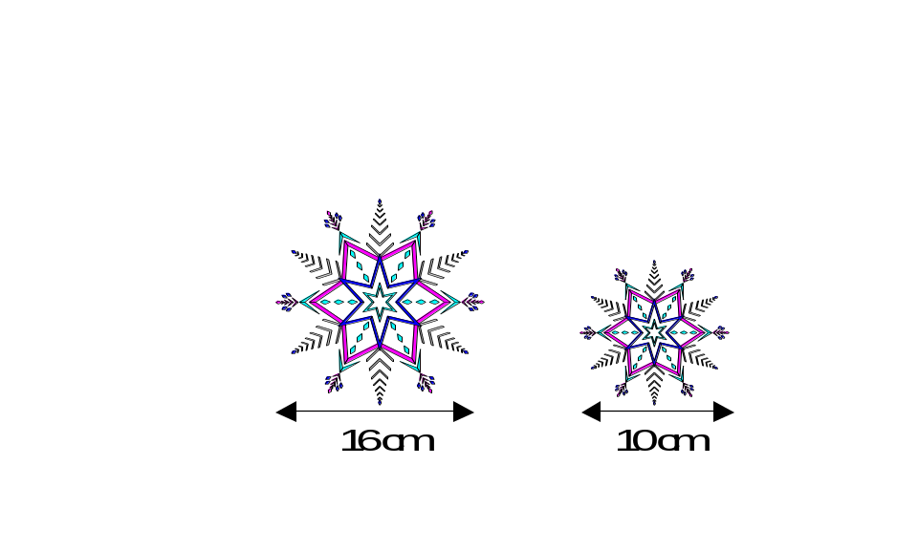6. Two Christmas decorations are mathematically similar
similar in shape.
The larger decoration has an area of 128 cm².

Calculate the area of the smaller decoration.

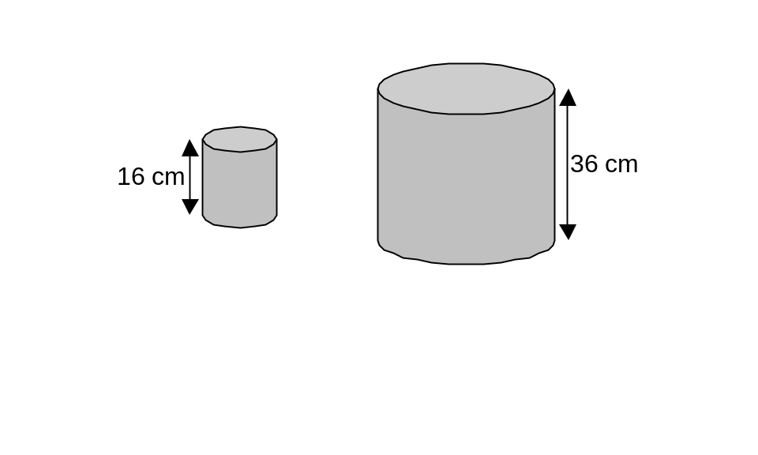

7. Two cylinders are mathematically similar.
The smaller cylinder is made from 800 cm²
of aluminium.

What area of aluminium is needed to make
the larger cylinder.

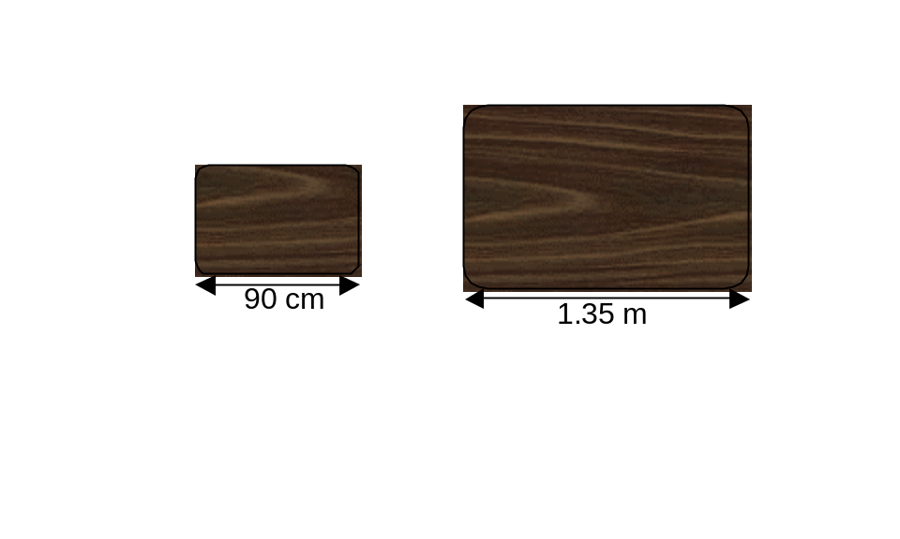

8. The top of a coffee table and the top of a
dining table are similar in shape.

The dining table is 1.35 metres long and
has an area of 0.9 m².

Calculate the area of the coffee table.
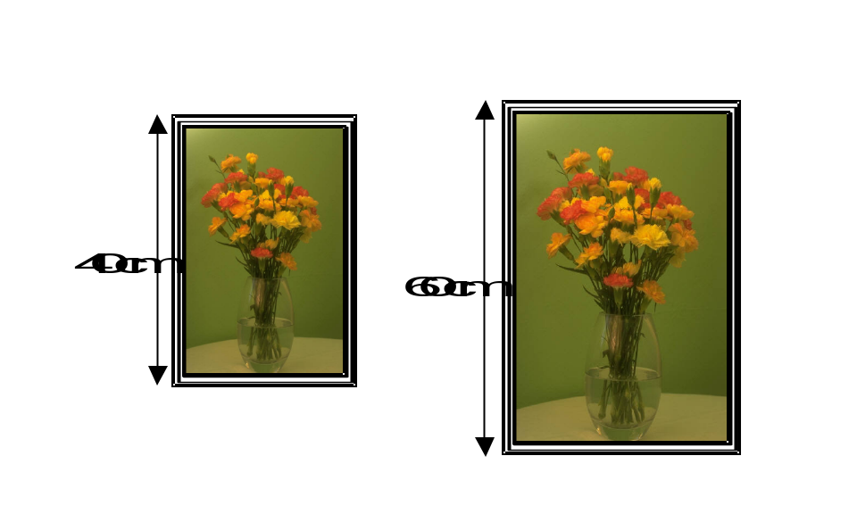

9. Two picture frames are mathematically
similar in shape.
The cost of the frames depends on their
area.
The smaller frame costs £4.60.
Find the cost of the larger frame.

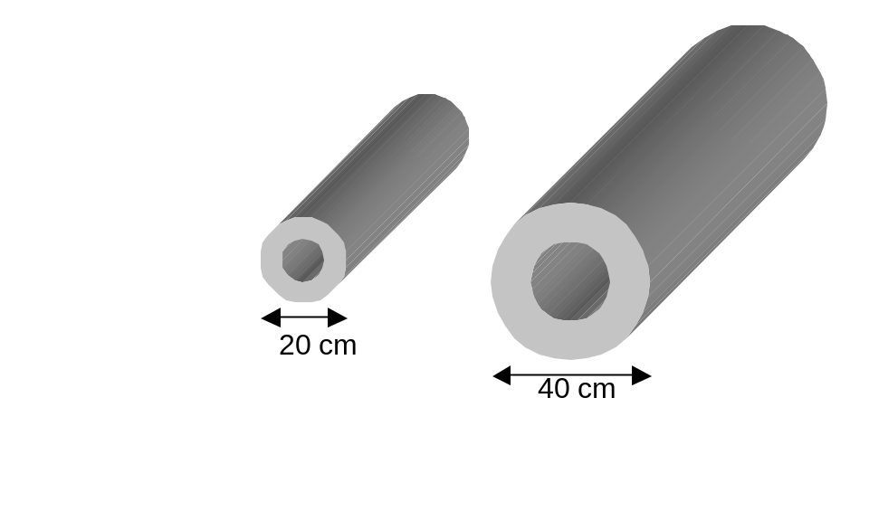

10. Two metal pipes are similar in shape.
The smaller pipe has a volume of
8000 cm³.

Find the volume of the larger pipe.
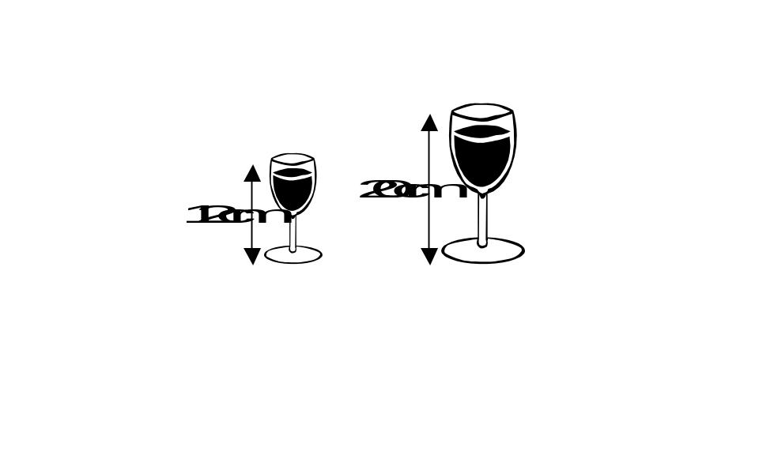

11. The wine glasses shown are similar
in shape.
The smaller glass can hold 135 ml
of wine.

How much wine can the larger glass
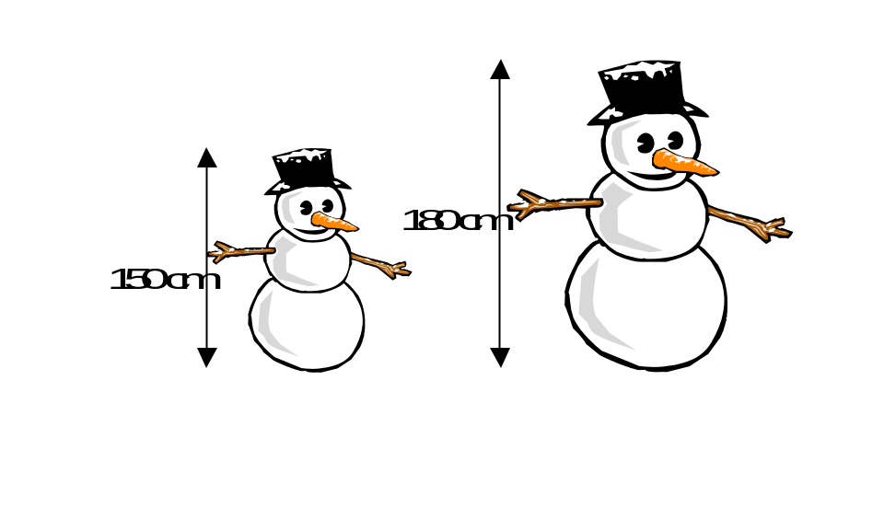 hold?

12. Michael and Amanda both build snowmen.
The snowmen they build are similar in shape.

The volume of snow in Michael’s snowman
is 30 000 cm³. His snowman is 150 cm tall.

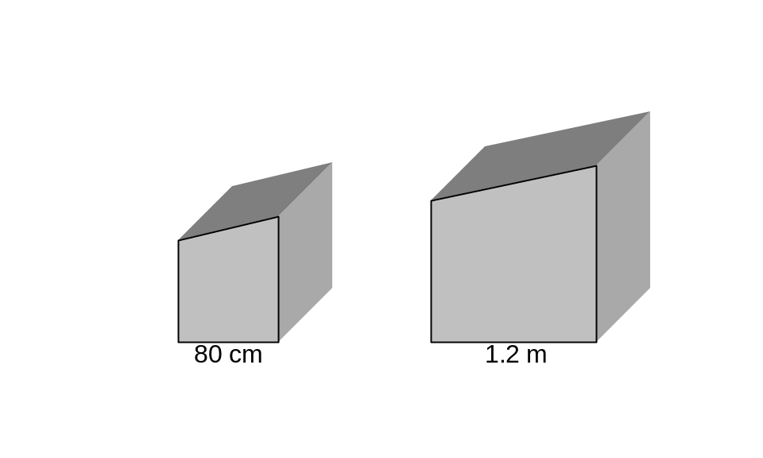 Calculate the volume of snow in Amanda’s
snowman.

13. Two storage bins are similar in shape.
The larger bin has a volume of 1.8 m³.

Calculate the volume of the smaller bin.
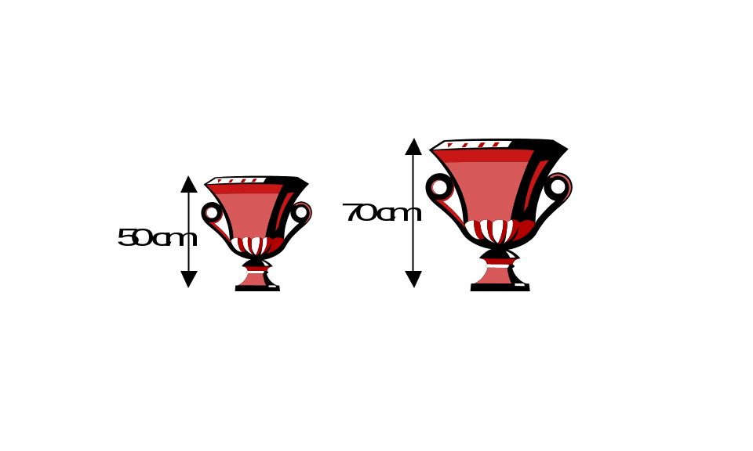

14. Two porcelain vases are similar in shape.
The volume of the smaller vase is 1200 cm³.

Calculate the volume of the larger vase.

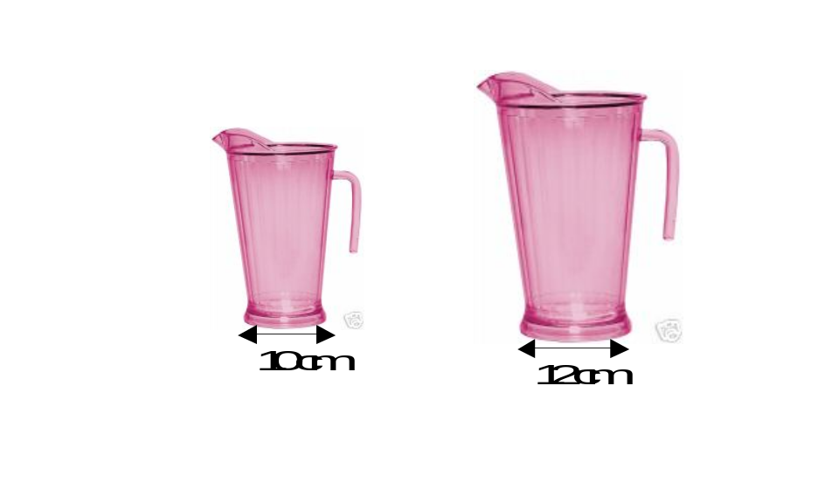

15. The pitchers shown opposite are similar.
The larger pitcher can hold 864 ml of
liquid.

How much liquid can the smaller pitcher hold?

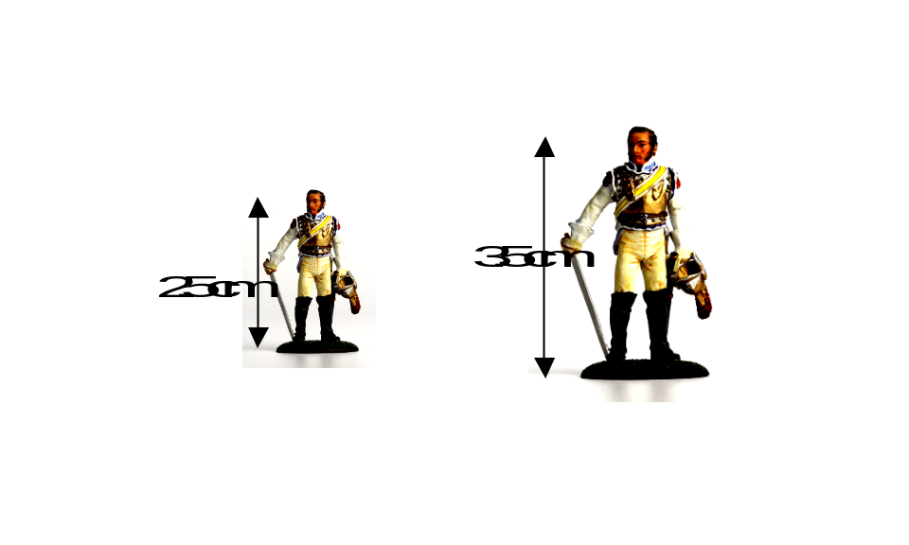
- Die-cast metal figures come in different sizes,
which are mathematically similar in shape.
The cost of each figure depends on the
volume of metal used to make the figure.

In the diagram opposite, the smaller figure
costs £1.25.
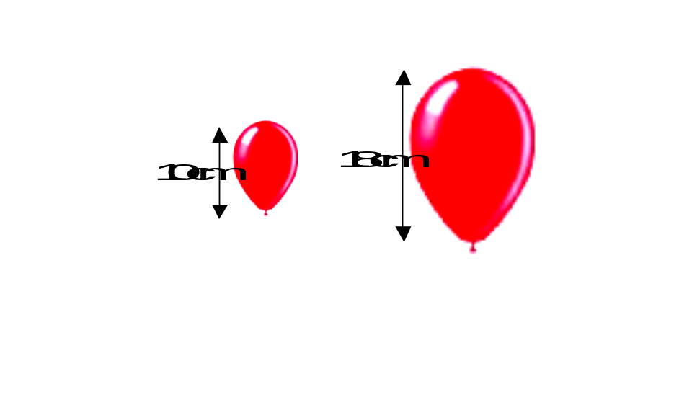Calculate the cost of the larger figure.

- The balloons shown opposite are similar in
shape. The larger balloon has a volume of
2187 cm³.

Calculate the volume of the smaller balloon.
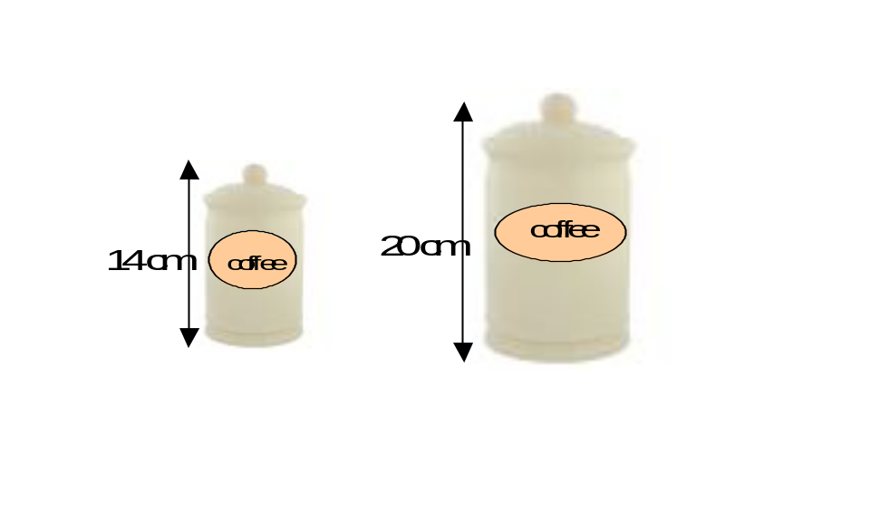

- A company sell coffee storage jars in
different sizes although each jar is
mathematically similar in shape.
The larger jar has a volume of 4000 cm³.

Find the volume of the smaller jar.
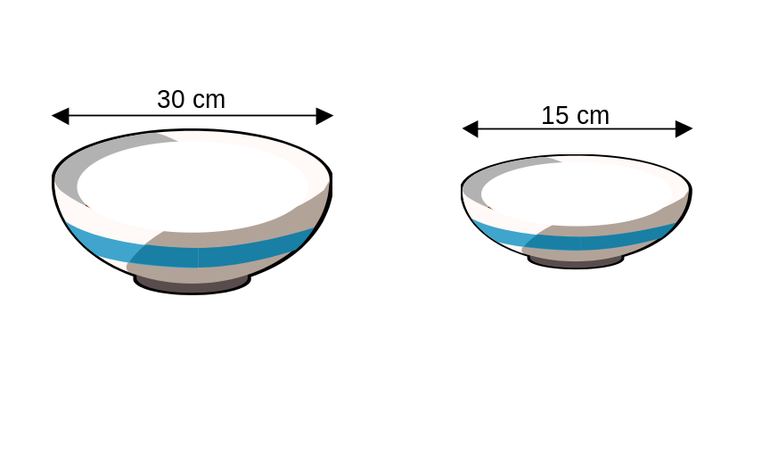

- The diagram opposite shows a pair of
similar fruit bowls.
The smaller bowl has a volume of
1400 cm³.

Find the volume of the larger bowl.

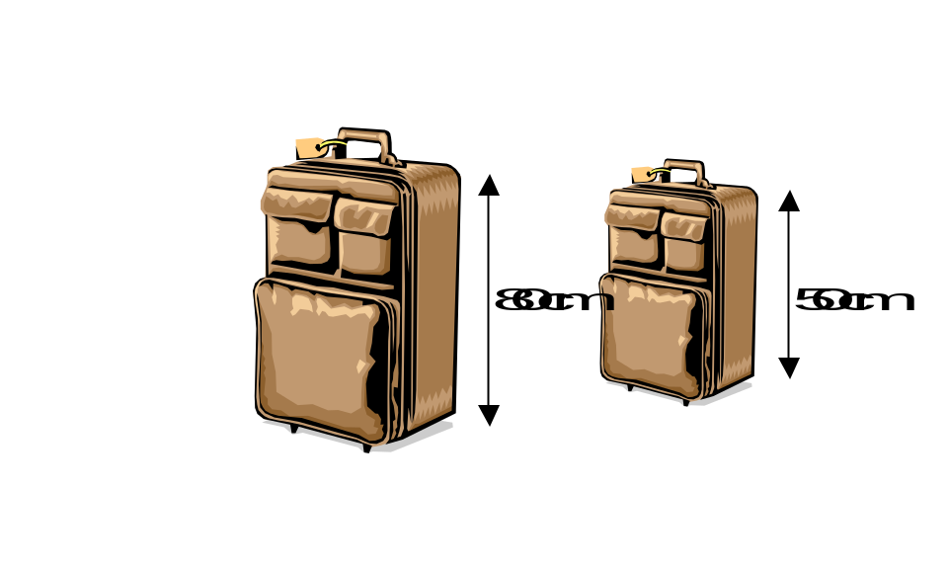

- The diagram shows two suitcases which
are mathematically similar in shape.
The cost of the suitcases depends on the
volume of items the suitcase can hold.

The larger suitcase costs £25.60, find the
cost of the smaller suitcase.

